HPC Lab Exp No.4

1.Addition of 2 large vectors:

#include <iostream>
#include <cuda_runtime.h>

__global__ void vectorAdd(float *A, float *B, float *C, int N) {
int idx = threadIdx.x + blockIdx.x * blockDim.x;
if (idx < N) {
C[idx] = A[idx] + B[idx];
}
}

int main() {
int N = 10;
size_t size = N * sizeof(float);
float *A, *B, *C, *d_A, *d_B, *d_C;
A = (float*)malloc(size);
B = (float*)malloc(size);
C = (float*)malloc(size);
cudaMalloc(&d_A, size);
cudaMalloc(&d_B, size);
cudaMalloc(&d_C, size);
for (int i = 0; i < N; i++) {
A[i] = i + 1;
B[i] = (i + 1) * 2;
}
cudaMemcpy(d_A, A, size, cudaMemcpyHostToDevice);
cudaMemcpy(d_B, B, size, cudaMemcpyHostToDevice);
int threadsPerBlock = 256;
int blocksPerGrid = (N + threadsPerBlock - 1) / threadsPerBlock;
vectorAdd<<<blocksPerGrid, threadsPerBlock>>>(d_A, d_B, d_C, N);
cudaMemcpy(C, d_C, size, cudaMemcpyDeviceToHost);
std::cout << "Vector A: ";
for (int i = 0; i < N; i++) {
std::cout << A[i] << " ";
}
std::cout << std::endl;
std::cout << "Vector B: ";
for (int i = 0; i < N; i++) {
std::cout << B[i] << " ";
}
std::cout << std::endl;
std::cout << "Calculations (A[i] + B[i]):" << std::endl;
for (int i = 0; i < N; i++) {
std::cout << "C[" << i << "] = " << A[i] << " + " << B[i] << " = " << C[i] << std::endl;
}
free(A);
free(B);
free(C);
cudaFree(d_A);
cudaFree(d_B);
cudaFree(d_C);
return 0;
}

OUTPUT:

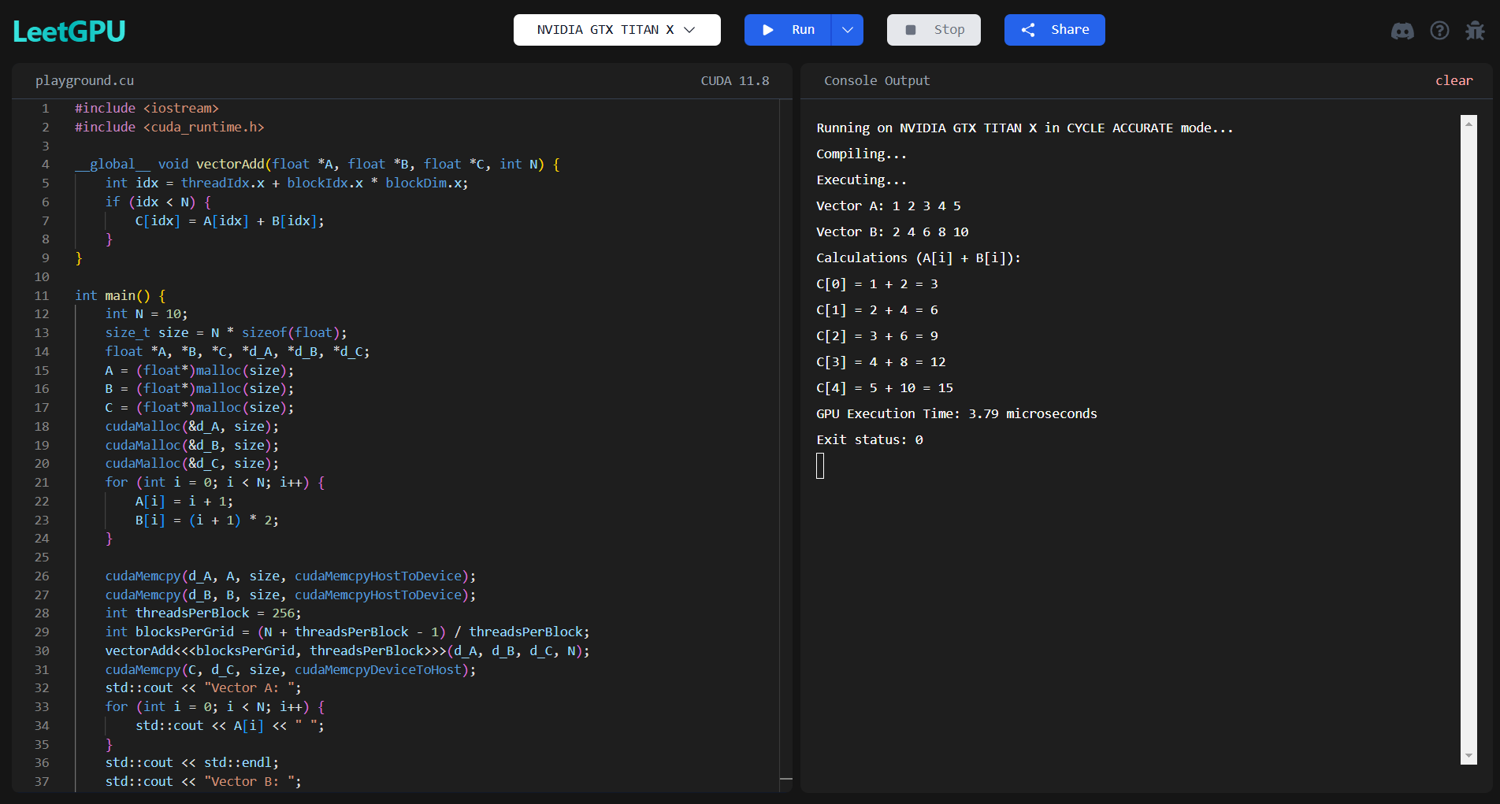

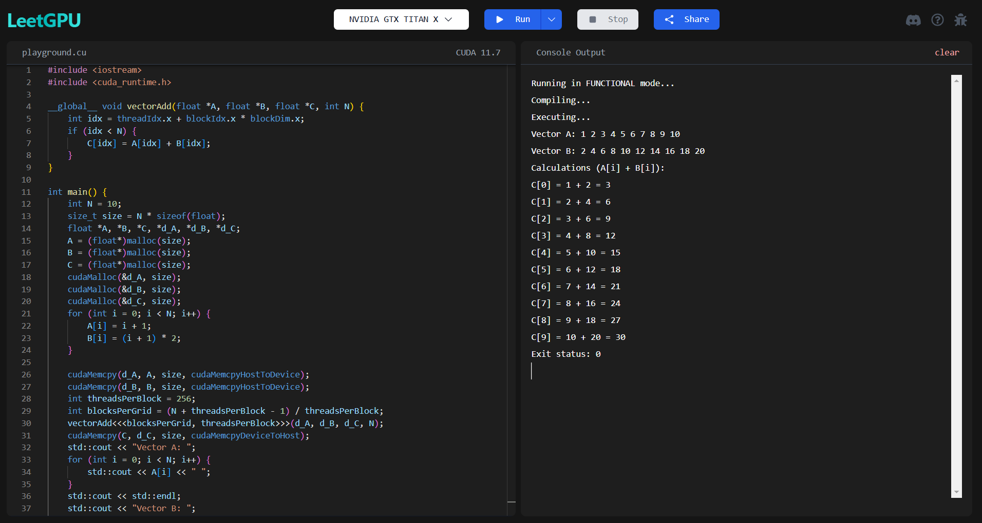

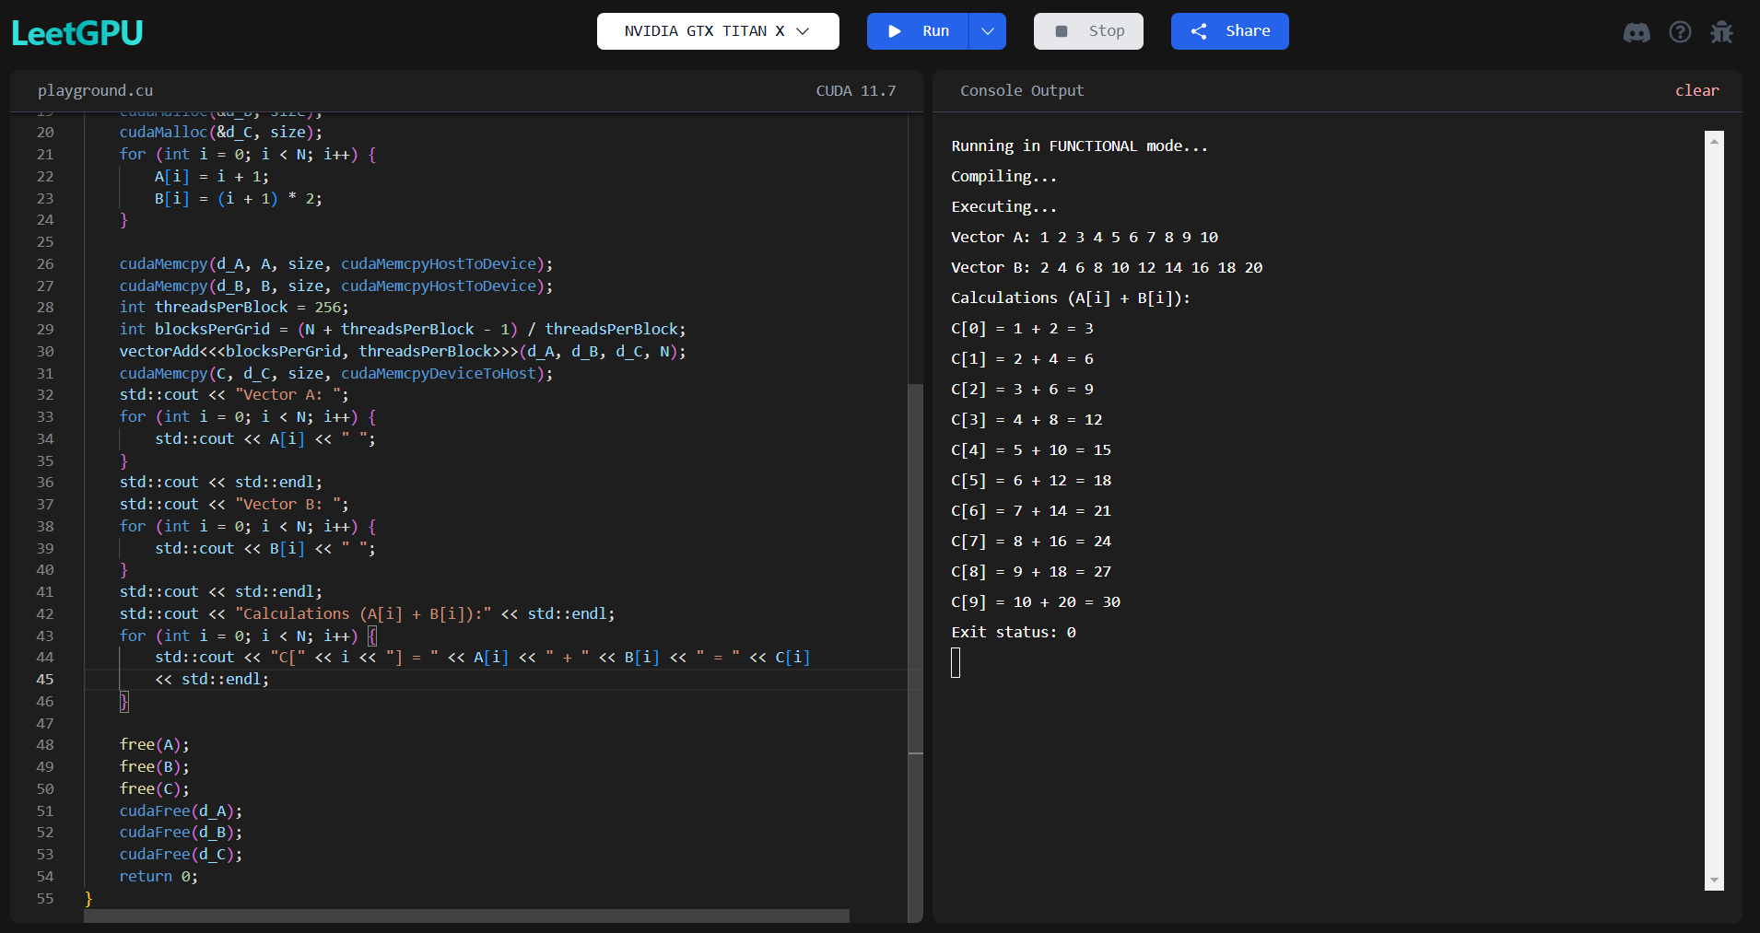
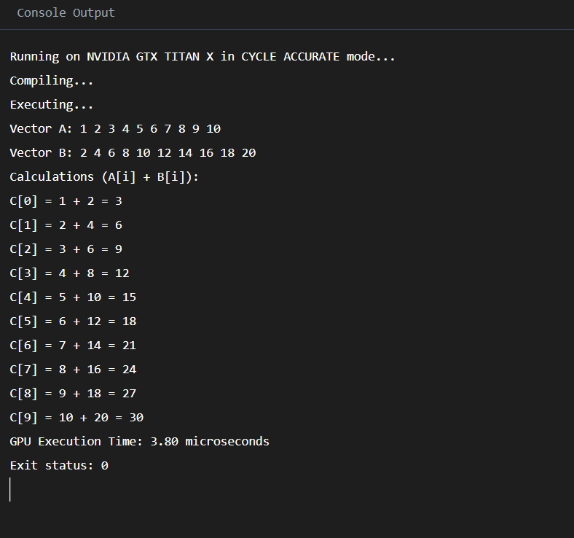

2. Matrix Multiplication:

#include <iostream>
#include <cuda_runtime.h>

__global__ void matrixMul(float *A, float *B, float *C, int N) {
int row = threadIdx.y + blockIdx.y * blockDim.y;
int col = threadIdx.x + blockIdx.x * blockDim.x;
if (row < N && col < N) {
float value = 0;
for (int k = 0; k < N; k++) {
value += A[row * N + k] * B[k * N + col];
}
C[row * N + col] = value;
}
}

int main() {
int N = 3;
size_t size = N * N * sizeof(float);
float *A, *B, *C, *d_A, *d_B, *d_C;
A = (float*)malloc(size);
B = (float*)malloc(size);
C = (float*)malloc(size);
cudaMalloc(&d_A, size);
cudaMalloc(&d_B, size);
cudaMalloc(&d_C, size);
for (int i = 0; i < N * N; i++) {
A[i] = (i % N) + 1;
B[i] = ((i % N) + 1) * 2;
}
cudaMemcpy(d_A, A, size, cudaMemcpyHostToDevice);
cudaMemcpy(d_B, B, size, cudaMemcpyHostToDevice);
dim3 threadsPerBlock(16, 16);
dim3 blocksPerGrid((N + threadsPerBlock.x - 1) / threadsPerBlock.x,
(N + threadsPerBlock.y - 1) / threadsPerBlock.y);

matrixMul<<<blocksPerGrid, threadsPerBlock>>>(d_A, d_B, d_C, N);
cudaMemcpy(C, d_C, size, cudaMemcpyDeviceToHost);
std::cout << "Matrix A:" << std::endl;
for (int i = 0; i < N; i++) {
for (int j = 0; j < N; j++) {
std::cout << A[i * N + j] << " ";
}
std::cout << std::endl;
}

std::cout << "Matrix B:" << std::endl;
for (int i = 0; i < N; i++) {
for (int j = 0; j < N; j++) {
std::cout << B[i * N + j] << " ";
}
std::cout << std::endl;
}

std::cout << "Calculations (C[i][j] = A[i][k] * B[k][j]):" << std::endl;
for (int i = 0; i < N; i++) {
for (int j = 0; j < N; j++) {
float value = 0;
for (int k = 0; k < N; k++) {
value += A[i * N + k] * B[k * N + j];
}
std::cout << "C[" << i << "][" << j << "] = ";
for (int k = 0; k < N; k++) {
std::cout << A[i * N + k] << "*" << B[k * N + j];
if (k < N - 1) std::cout << " + ";
}
std::cout << " = " << C[i * N + j] << std::endl;
}
}

free(A);
free(B);
free(C);
cudaFree(d_A);
cudaFree(d_B);
cudaFree(d_C);
return 0;
}

OUTPUT:

